**Benjamín Valdez Rodríguez**

**A00822027**

**Código**

//

// main.c

// P3 Tipos de datos y sizeof

//

// Created by Benjamin Valdez on 2/21/20.

//

#include <stdio.h>

#include <float.h>

**int** main(**int** argc, **const** **char** * argv[]) {

**int** input1 = 0;

**char** input2 = ' ';

**double** input3 = 0;

printf("Give me a integer: ");

scanf("%d", &input1);

printf("Give me a char: ");

scanf("%s", &input2);

printf("Give me a double: ");

scanf("%lf", &input3);

printf("\nYour integer <%d> storage size is <<%lu>> bytes\n", input1, **sizeof**(input1));

printf("Your char <%c> storage size is <<%lu>> bytes. And I can read it as <<%c>> or as <<%d>>\n", input2,**sizeof**(input2), input2, input2);

printf("Your double <%f> storage size is <<%lu>> bytes, I can read any number from <<%f>> to <<%f>> in this data type.\n", input3, **sizeof**(input3), DBL_MIN, DBL_MAX);

**return** 0;

}

**Caso de Prueba 1**

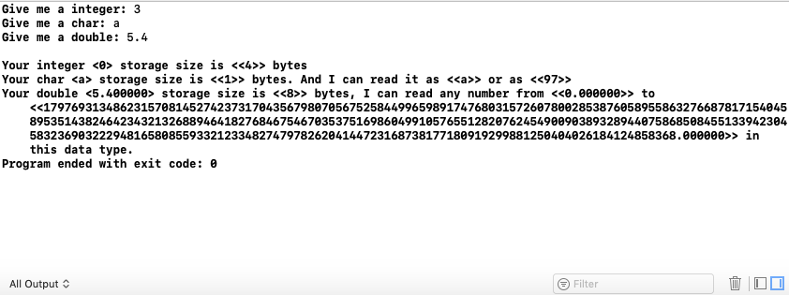

**Caso de Prueba 2**

